Community Member Discovery for Admin
Users  - Primary  - Community page creator (admin)  - Secondary  - … | Phase 1
Intended Outcome
- Equip community organizers with tools to monitor the distribution of joined members and identify which groups have not yet joined the community.
- Enable organizers to view key member identification fields, internal approval notes, and member WhatsApp numbers, so they can reach out and request help connecting with or inviting groups that are underrepresented or missing from the community
Links
- …
- …
- …
- …
- …

Introduction
Admin Community Member Discovery provides community organizers with an enhanced directory, focused on tracking the membership completeness of their community. This feature allows admins to see not just who has joined, but which identity groups are well-represented and which still have gaps. Through a dashboard similar to the standard member directory—but enriched with approval notes and WhatsApp contacts, organizers can find key members, understand their join status, and directly reach out to bridge coverage gaps.

With this toolkit, admins can identify clusters of members who have not yet joined, contact relevant alumni or group representatives via WhatsApp, and encourage them (or their networks) to get connected. By making it easy for admins to detect and solve “missing group” issues, this epic supports a more inclusive, engaged, and well-connected community, ensuring no group is left behind in the onboarding process.

Product Requirement
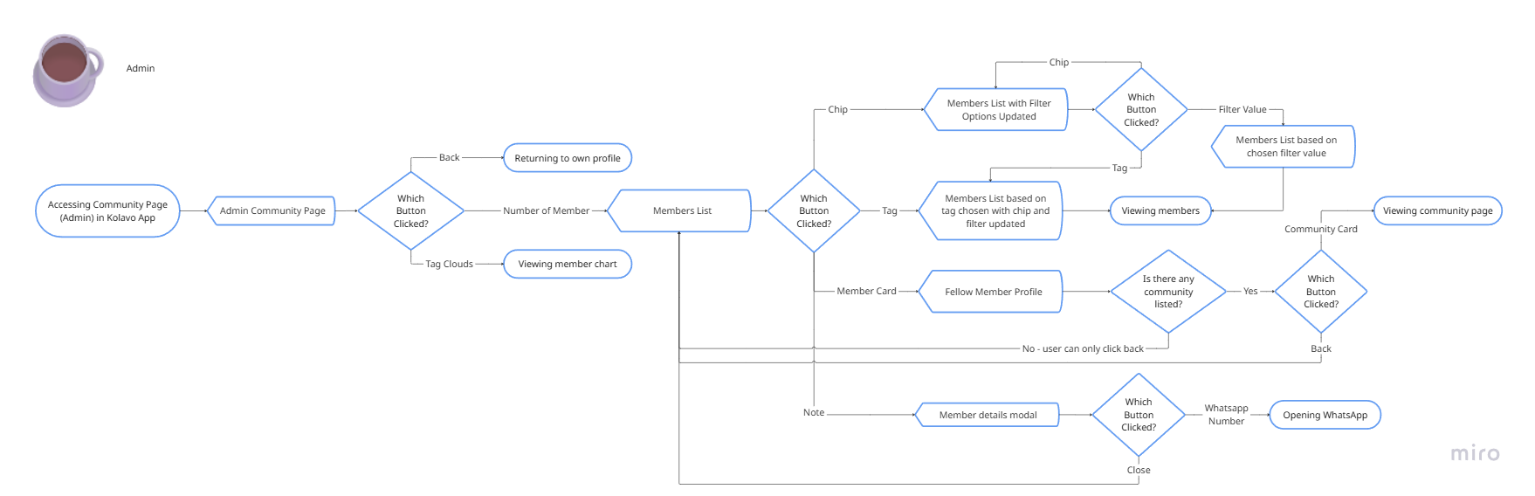
Community Member Discovery for Admin Flow

No | User story | Scope | Acceptance Criteria
1 | As a community organizer, I want to have access to a list of community members, so I know what to do when I need it. | Admin Community Member Directory Flow | - Users must logged in and access community where they are admin  - At the community page, in the member section, showing total number of members which is clickable and directs to list of community members when clicking it.
1 | As a community organizer, I want to view a directory of all accepted members, so that I can easily monitor who has joined my community and review their key identity information. | Admin Community Member Directory | - The page displays a clear header and a subheader explaining that organizers can review members by group or segment using filters.  - Only organizers/admins can see this page and its contents.  - The directory shows all currently accepted members.  - Members who are pending/rejected/removed do not appear.
2 |  | Admin Community Member Directory
3 | As a community organizer, I want to filter members based on specific identity groups, so that I can easily find and reach out to certain clusters within the community. | Group Chips & Quick Filter | - A row of group chips which are [question title] appears at the top.  - Clicking a chip filters the member list by that identity field.  - A secondary dropdown allows filtering by value within the chip which are the answers of the questions in registration form.  - Only identity fields and categories with joined members appear as chips.  - Filtered results update member cards below, no page reload.
4 | As a community organizer, I want to see member identifications in an attractive way as well as functional, so I can easily know who the members are and filter based on who they are. | (Member Identification as) Tags | - Show member identification as tags  - Each tag has color that represent each chip  - Clicking each tag auto choosing chip and filter value.
5 | As a community organizer, I want to view each member’s key identity info, approval note, and WhatsApp number, so I can review statuses and contact members to help invite others. | Member Cards (with admin info) | - Member cards are displayed for all accepted members in the filtered group.  - Each card shows:  - Profile photo/initials  - Nickname (nama panggilan)  - Membership identity answers  - WhatsApp number (for admin eyes only, never exported to members/users)  - Approval note (internal, admin-only)  - Clicking WhatsApp number allows open in WhatsApp Web/app  - Cards are responsive and easy to scroll/browse, with filters always visible at the top.
6 | As a community admin, I want to see what other communities that my fellow members join, so I can know what other communities exist that I can also join. | Fellow Member Community Profile | - Fellow member community profile is a page containing a public personal profile and list of communities joined.  - Rejected and pending communities not shown.  - This page can only be accessed by fellow members through communities they are in.  - Personal profile include:  - Profile picture  - Nickname related to communities  - Domicile (if filled)  - Communities include:  - Logo  - Community abbreviation  - Membership status

Design Requirement
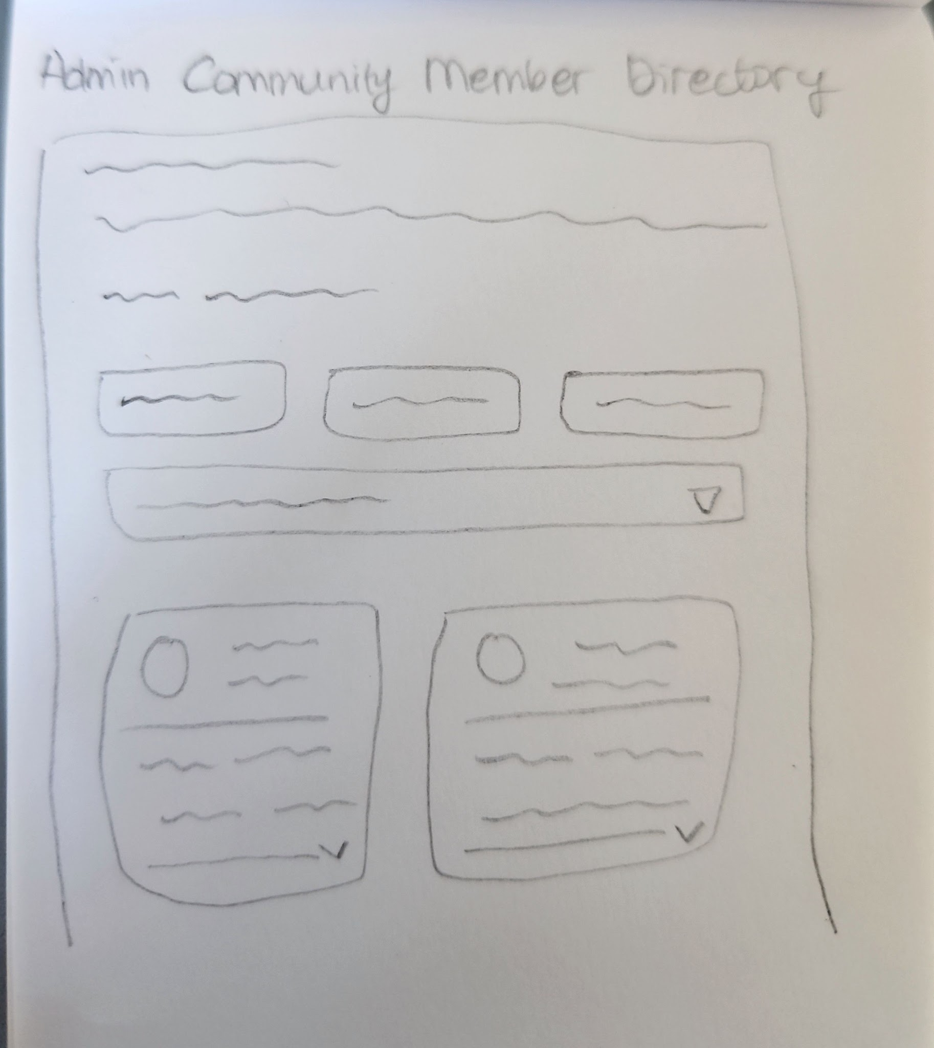

Community Page Member Section

Admin Community Directory Button
Design Intent | To give admin access to community directory
Content / Copy | - Total member count displays: [Number of Member] Anggota
Visual Requirement
Interaction Behavior | - Clicking [Number of member] directs to admin community members directory
Acceptance Criteria

Admin Community Member Directory

Breadcrumbs
Design Intent | To make admins aware where they are and how to go back to previous page
Content / Copy | - < Daftar Anggota
Visual Requirement
Interaction Behavior | - Clicking < returns to previous page
Acceptance Criteria

Heading and Subhead
Design Intent | To make admins aware about what the page is
Content / Copy | - Heading: Anggota [Community Shortname]  - Subhead: Pantau representasi anggota dan bantu komunitasmu tetap terhubung dan lengkap
Visual Requirement
Interaction Behavior
Acceptance Criteria

Group Chips and Filter
Design Intent | To ease admins finding certain group of members
Content / Copy | - Chips name: [question title]  - Filter:  - Filter label: Filter:  - Placeholder: Pilih [question title]  - List of filter: [answers from selected question title]
Visual Requirement
Interaction Behavior | - Content filter changes as users click each chip  - Member cards shown changes as users click each chip and filter
Acceptance Criteria

List of Member Cards
Design Intent | To ease admins understanding their community members at glance
Content / Copy | - Member Profile  - Member profile picture  - Member nickname  - Member community identities
Visual Requirement
Interaction Behavior | - Clicking a member card opens a member card modal  - Clicking each of member community identities activates related chips and filters
Acceptance Criteria

(Member Identification as) Tags
Design Intent | To ease admins scanning and filtering their members
Content / Copy | - Tags: maximum 5 of [member identifications]
Visual Requirement | - The order of tag is same with the order of chips  - Each tag shows different color representing chip/category
Interaction Behavior | - Clicking one of tags auto selecting chips and filter value which results showing member cards based on chips and filter value
Acceptance Criteria

Member Card Modal
Design Intent | To allow admins understand more about their community members
Content / Copy | - Member Profile  - Member profile picture  - Member fullname  - Whatsapp number  - Member nickname  - Member ID  - Member community identities  - Member approval history  - Notes  - Joined date  - Approved by
Visual Requirement
Interaction Behavior | - When admin click on the whatsapp number, whatsapp web app opens to start chatting with the member
Acceptance Criteria

Fellow Member Profile
Design Intent | To allow members knowing fellow members by looking and exploring at fellow members profile and communities
Content / Copy | - Member Profile  - Member profile picture  - Member nickname  - Domicile  - Communities:  - Logo  - Community abbreviation  - Membership status  - Admin: Pengurus  - Member: Anggota
Visual Requirement | - Membership status using Kolavo brand colour  - Admin colour using blue  - Member colour using orange
Interaction Behavior | - Clicking one of community cards directs to selected community page
Acceptance Criteria

Engineering Requirement

Questions

